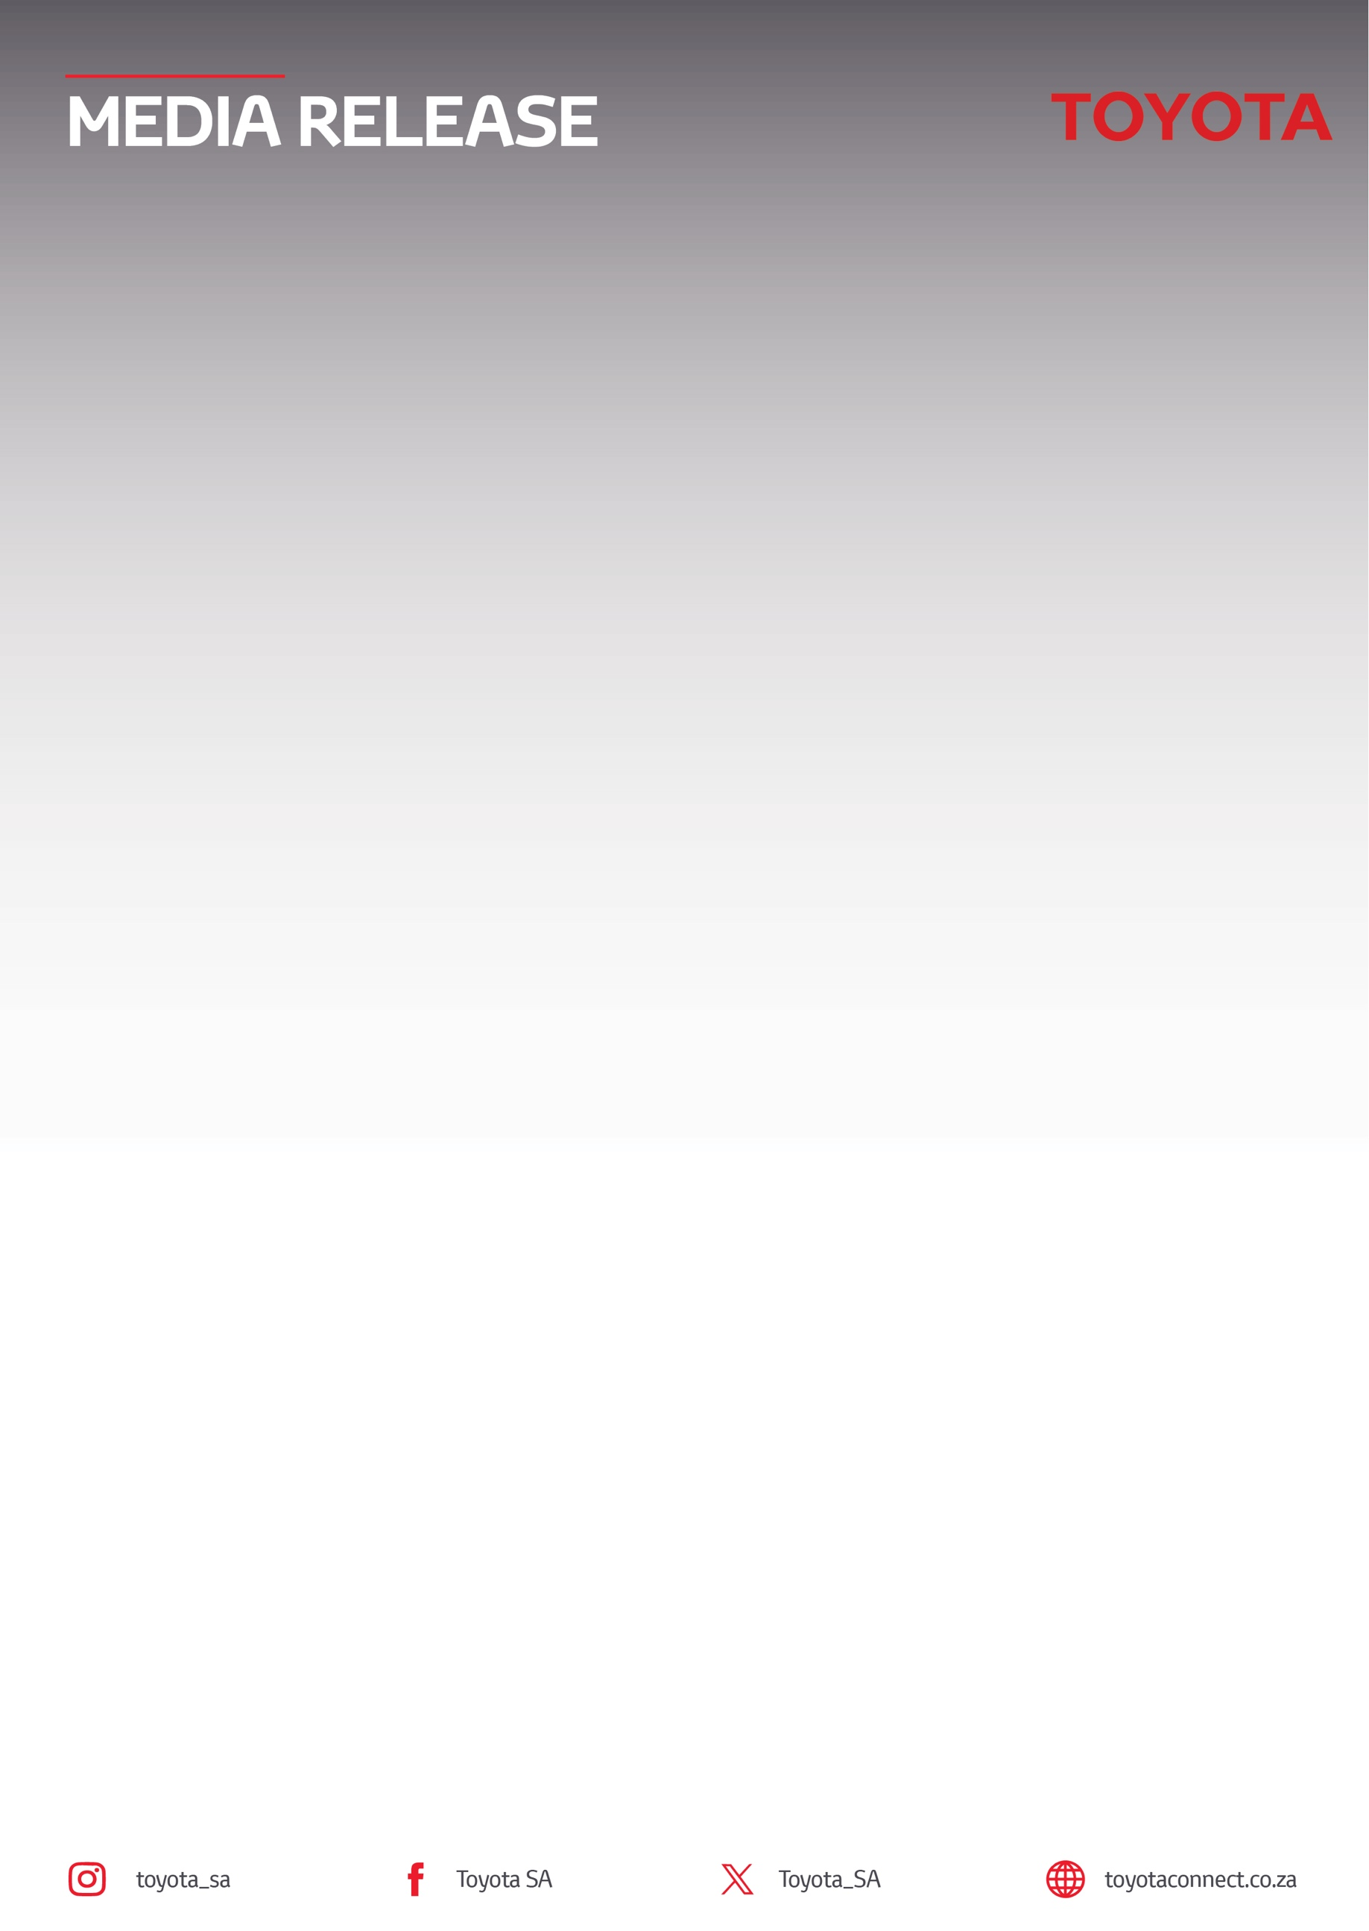
03 November 2026

Toyota South Africa Motors retains market leadership with a
23.4% share as industry momentum continues

- Fifty percent of new vehicle sales from passenger cars
- Leadership in Passenger, LCV and MCV
- Hilux remains best-selling model in South Africa, with a market share of 30.4%
- Toyota’s parts operations performance maintains strong momentum
Sandton – Toyota South Africa Motors (TSAM) recorded 14 495 new vehicle sales in October 2026, maintaining its position as South Africa's leading automotive brand with a market share of 23.4%. Toyota's performance was supported by strong passenger vehicle demand, continued leadership in the Light Commercial Vehicle (LCV) and Medium Commercial Vehicle (MCV) segments, as well as positive momentum across its parts operations.
According to the latest figures released by naamsa | The Automotive Business Council, the domestic new vehicle market recorded 61 890 sales in October 2026, compared to 56 051 units in October 2025, reflecting continued growth in industry demand. Toyota's sales increased from 13 559 units in October 2025 to 14 495 units this year, reinforcing the brand's continued appeal across both private and business customers.
Commenting on Toyota’s performance, Leon Theron, Senior Vice President for Sales and Marketing at Toyota South Africa Motors said, "Maintaining a market share of 23.4% in a highly competitive environment is a testament to the strength of our portfolio and the trust South Africans continue to place in the Toyota brand. From passenger vehicles and commercial products to parts and fleet solutions, our focus remains on delivering quality, reliability and long-term value."

Brand Performance
Toyota's passenger vehicle line-up remained a key contributor, accounting for more than half of Toyota's total monthly sales. A diverse and well-balanced portfolio continued to resonate with customers across multiple segments, from entry-level mobility to family SUVs.
The Corolla Cross (1 723 units) and Starlet Cross (1 611 units) both secured places among South Africa's top-selling passenger vehicles during October. Additional strong performers included the Vitz (1 091 units), Starlet (1 081 units), Urban Cruiser (939 units) and Fortuner (894 units).
Within the premium vehicle segment, Lexus delivered 84 units in October. The GX remained the brand's strongest performer with 26 units sold, followed closely by the LX (22 units) and NX (20 units), despite continued competitive pressures in the luxury market.
Toyota maintained its dominance in the LCV segment, with the Hilux recording 3 820 sales and a segment-leading market share of 30.4%. Supporting this performance were the Hiace (600 units) and Land Cruiser 79 Pick-Up (384 units), highlighting continued demand for Toyota's trusted commercial vehicle range.
In the MCV market, Hino continued its positive trajectory with the 300 series increasing sales to 146 units, up from 129 units in September 2026. In the Heavy Commercial Vehicle segment, the Hino 500 and Hino 700 delivered a combined 129 units, reinforcing Hino's role as a dependable transport partner for South African businesses.
Toyota also maintained a strong presence in the fleet sector, serving more than 2 000 customers across industries including agriculture, mining, construction, logistics and transport. Continued demand from these sectors underscores the strength of Toyota's dealer network and the trust placed in its products despite ongoing economic pressures.
In parts operations, Toyota surpassed the milestone of two million domestic parts sold during October. Export volumes reached 414 250 units, representing growth of approximately 21.9% compared to September's 339 851 units and reflecting strengthening demand across regional markets.
“We are grateful for the continued confidence that South Africans place in our brands. Every vehicle sold, fleet partnership and customer interaction reflects a relationship built on trust. On behalf of Toyota South Africa Motors, I would like to thank our customers, dealers, employees and business partners for their ongoing support as we continue to move the country forward together,” concluded Theron.

ENDS.
Refilwe Ramatlhodi Ndhlovu
Manager: Corporate Communication
Toyota South Africa Motors
rramatlhodindhlovu@toyota.co.za
www.toyota.co.za

