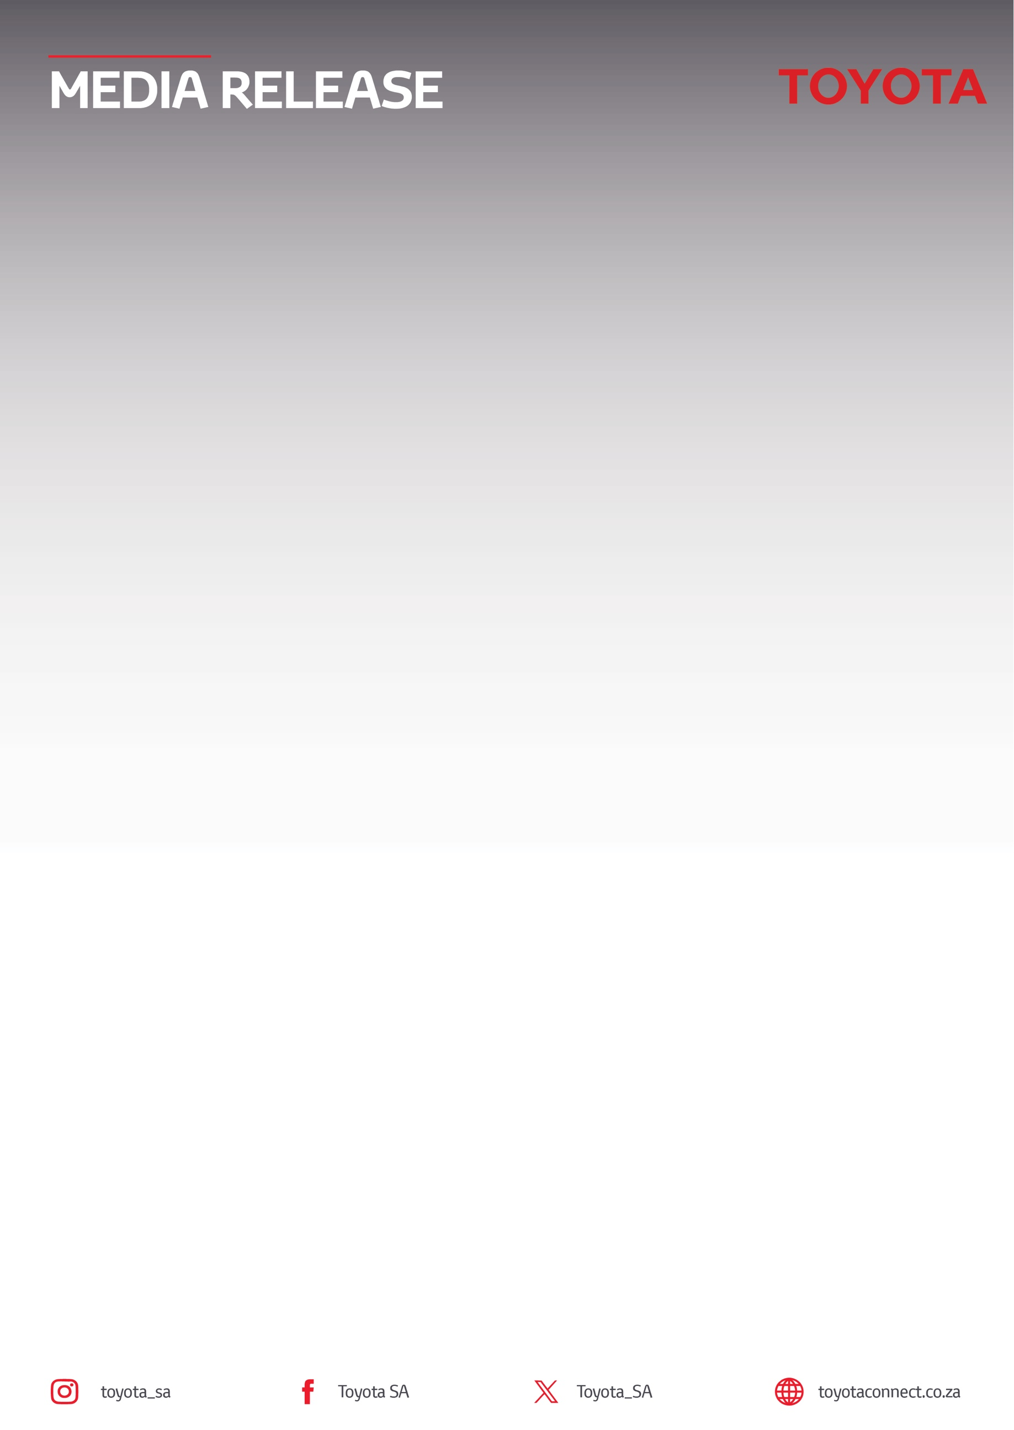
05 November 2026

Toyota South Africa Motors leads the gees for
FNB Wines2whales 2026

Cape Town – For the 5th consecutive year, Toyota South Africa Motors (TSAM) is excited to be the Official Vehicle Partner of the FNB Wines2Whales, South Africa's much loved “race with gees” that winds through the Overberg's wine farms and coastline. This year, the spotlight falls on the brand-new 9th generation Toyota Hilux, which will lead the fleet supporting riders, officials and crew across all three legs of the race.
As the Official Vehicle Partner, Toyota's fleet will keep the event running behind the scenes, transporting race officials and providing logistical support along the route to ensure staff, crew and participants have a seamless experience from start to finish.
Commenting on the partnership, Glenn Crompton, Vice President: Marketing at Toyota South Africa Motors said, “The FNB Wines2Whales reflects the same values Toyota stands for: reliability, adventure and creating memorable experiences. Through our partnership, we are proud to support the logistics of the race, enhance the rider experience and introduce the new Hilux to a community of riders and fans who share our passion for capability and adventure.”

Three Legs, One Race with Gees
The FNB Wines2Whales runs across three categories, each following the same route on its own dates: Chardonnay (6 to 8 November), aimed at Elite Women's and Age category teams; Pinotage (9 to 11 November), reserved for E-Bike riders; and Shiraz (13 to 15 November), home to the Elite Men's and Elite Mixed categories. Toyota's focus for 2026 is firmly on the experience the brand brings to riders and spectators across all three legs.

More Gees on the Route
The Toyota Cruise Sections return for 2026, bringing fun obstacles to elevate each race day and giving riders a change of pace along the route. Toyota will also offer Luxury Route Tours to transport VIP guests to exclusive vantage points.

Toyota is also proud to drive the Toyota Mixed Category, the race's team format for one man and one woman riding together.

Sim Racing at the FNB Recharge Zone
Toyota will plug riders into action-packed down time, with two sim racing rigs giving everyone a chance to compete when putting their feet up at the FNB Recharge Zone.

Backing Local Talent
Toyota continues to invest in South African riding talent, with the Toyota Specialized Imbuko team once again lining up for the 2026 race. Several of the riders return after standout performances last year:
- Tristan Nortje (alongside fellow Toyota Specialized Imbuko rider Marco Joubert) climbed from 5th to 3rd overall after taking the win on Stage 2, just 2:55 behind the leaders.
- Jaedon Terlouw sat 2nd overall after Stage 1, dropped to 6th on Stage 2, then fought back to finish 2nd on the final stage and 3rd overall.
- Inus du Preez and Lood Goosen delivered their best results on Stage 3, finishing 5th overall.
A partnership built on shared values
With its mix of competitive racing and camaraderie, the FNB Wines2Whales remains one of South Africa's most loved cycling events, and Toyota is proud to help carry the gees forward for another year.

For more information on Toyota’s brand partnerships, please visit Toyota Community Sponsorships | Toyota South Africa.
ENDS.
Refilwe Ramatlhodi Ndhlovu
Manager: Corporate Communication
Toyota South Africa Motors
rramatlhodindhlovu@toyota.co.za
www.toyota.co.za

