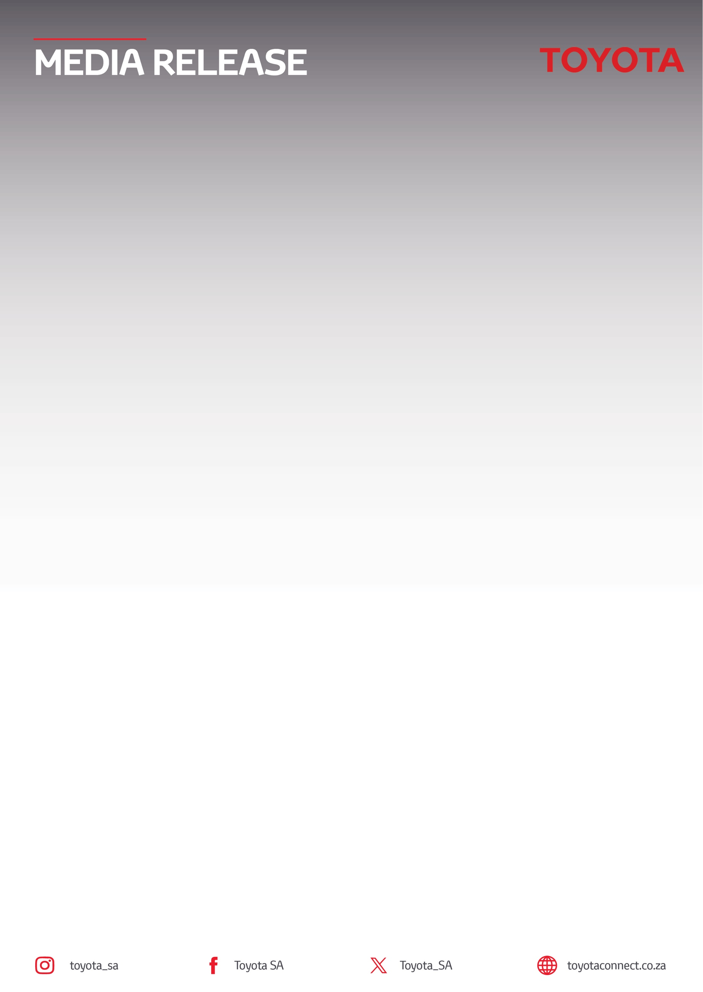
20 October 2026

Toyota South Africa Motors returns as Official Vehicle Partner for the 2026 Nedbank Gravel Burn

Sandton, South Africa – Toyota South Africa Motors (TSAM) has confirmed its return as Official Vehicle Partner of the Nedbank Gravel Burn, a 750km, 7-day gravel stage race that departs from Robert Sobukwe (formerly Graaff Reinet) Town on 25 October and finishes at Shamwari Private Game Reserve on 31 October.

A fleet of 16 Toyota vehicles will underpin the event's operations in this 2nd edition, supporting race stakeholders and ensuring a seamless experience for staff, crew and participants across the route through the Great Karoo.

New for 2026, Toyota has introduced the Toyota Power Climber Jersey, recognising the best uphill rider across both Pro and Age Group categories, as well as the overall best climber. The jersey will be contested on three of the race's seven stages.

Toyota's presence on the gravel will be equally formidable through its sponsored professional cycling teams, Toyota Specialized Off-Road and Toyota Specialized Imbuko. Competing in the Pro category, an elite line-up of riders including Matt Beers, Marco Joubert, Tristan Nortje, Travis Stedman, Jaedon Terlouw, Inus du Preez and Lood Goosen will proudly represent the brand. As a solo stage race, riders compete individually for the overall leader jersey in their category, while still representing their team.

Building on a strong debut
Toyota-backed riders were central to the story of the inaugural 2025 Nedbank Gravel Burn. Matt (Toyota Specialized Off-Road) claimed the overall Pro Men's title, winning three of the seven stages and holding the race lead from Stage 1 through to the finish at Shamwari, ultimately crossing the line 5 minutes and 26 seconds clear of Switzerland's Simon Pellaud after more than 800km of racing through the Great Karoo. Tristan completed the race in 4th place overall, while Travis capped the week with victory on the final stage into Shamwari. Their performances helped establish the standard that the Toyota-backed line-up will look to build on in 2026.

Toyota's involvement extends beyond the elite field. Several amateur riders will also take on the Nedbank Gravel Burn under the Toyota banner. They include Reuben van Niekerk (who competes in the adaptive rider category); adventure cyclist and women’s sports advocate, Tegan Philips; semi-pro rider and Sub-veteran gravel champion Bianca Nel and founder of The Active Hobo media platform, David Jenkins.

Toyota wishes them and every rider taking on this tough seven-day challenge, the very best of luck.

For more information on Toyota’s brand partnerships, please visit Toyota Community Sponsorships | Toyota South Africa.
ENDS.
Refilwe Ramatlhodi Ndhlovu
Manager: Corporate Communication
Toyota South Africa Motors
rramatlhodindhlovu@toyota.co.za
www.toyota.co.za

