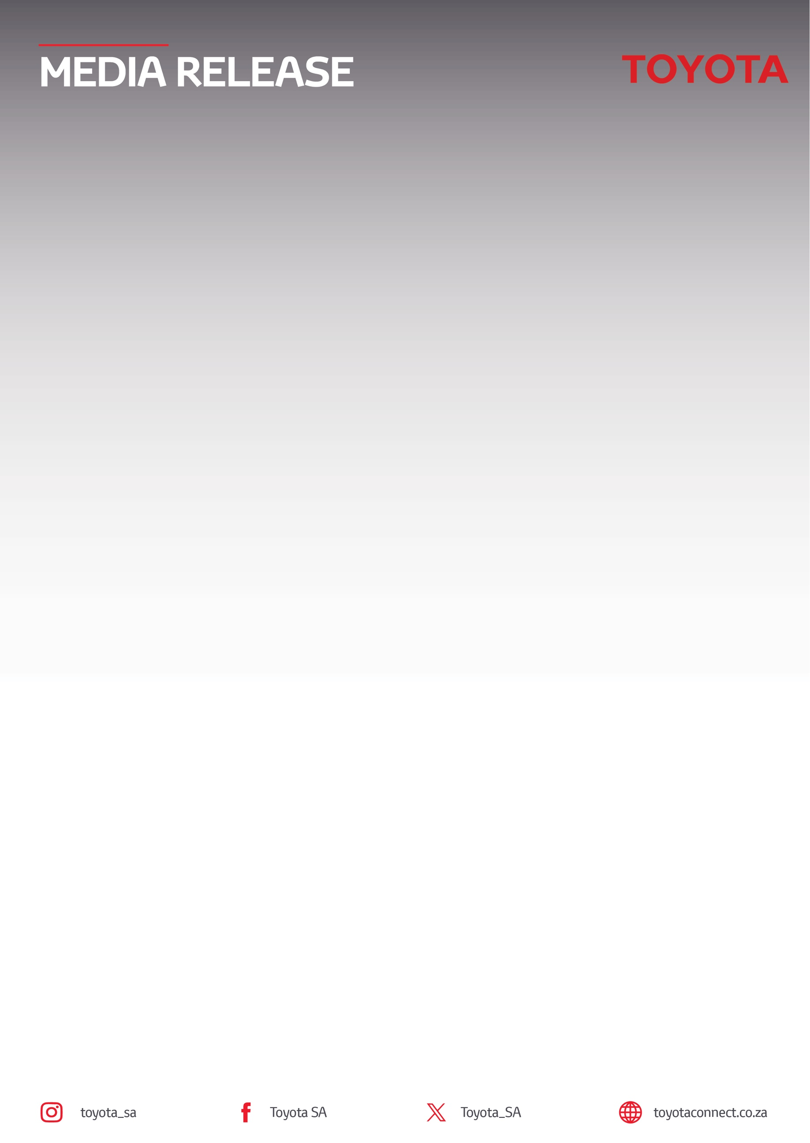
21 October 2026

Toyota South Africa Motors invites South Africans to design the Official Comrades Centenary Cap

Sandton – For more than two decades, Toyota South Africa Motors has proudly partnered with the Comrades Marathon as its official vehicle and mobility sponsor, helping support one of the country's most iconic sporting events.
Each year, Toyota vehicles play an important role in enabling race operations, logistics and athlete mobility along the route between Pietermaritzburg and Durban. From lead vehicles and race officials to medical support and logistics teams, Toyota's fleet helps keep the world's largest and oldest ultramarathon moving. Along the route, the iconic red-and-white Toyota Last Mile serves as a reminder of the determination, resilience and achievement that define the Comrades experience.
As the Comrades Marathon prepares to celebrate its centenary in 2027 under the theme, The Greatest Story Ever Run, Toyota is offering South Africans a unique opportunity to become part of that story by designing the official Comrades Centenary Cap.
For many runners, the annual Comrades Cap is more than simply a race accessory. It is a cherished memento that represents months of preparation, personal sacrifice and the accomplishment of crossing the finish line. In 2027, that cap will carry even greater significance as runners take part in a historic edition of the race.
Through The Greatest Cap Ever Worn competition, members of the public are invited to submit a design for the official commemorative cap that will be included in every participant's race pack for the 100th Comrades Marathon. With approximately 28,000 runners expected to take part, the winning design will be worn and treasured by thousands of participants from South Africa and around the world.

How to Enter
The competition is officially open and will close on 30 October 2026. Those interested in entering their designs are encouraged to visit www.toyotacomradescap.co.za to download the official design template and view the competition terms and conditions. The winning design will be announced on 13 November 2026 - post shortlisting and public voting between 2-12 November 2026.

Prize Package
The winning designer will receive:
- A VIP Comrades Marathon hospitality experience.
- Travel or flights to Durban.
- One night’s accommodation.
- An invitation to the exclusive Comrades sponsor and partner dinner.
- An entry into the Comrades Marathon Toyota Win-A-Car lucky draw.
- The winning cap design, mounted on a display and signed by Comrades champion and ambassador for Global Team Toyota Athlete, Gerda Steyn.
- Wearable technology prize package valued at R11 500.00.

"The Comrades Marathon has always been about people, perseverance and the incredible stories that emerge along the journey to race day. As we look ahead to the centenary edition of this remarkable event, we wanted to create an opportunity for South Africans to leave their own mark on its history. The Comrades Cap is a meaningful keepsake for many runners and we're excited to see how participants interpret the spirit, heritage and significance of the 100th running of the race through their designs," said Tasneem Lorgat, General Manager: Marketing Communications at Toyota South Africa Motors.
Toyota looks forward to celebrating the creativity of South Africans while continuing to support the runners, organisers, volunteers and communities that make the Comrades Marathon one of the country's most enduring sporting traditions.
For more information on Toyota’s brand partnerships, please visit Toyota Community Sponsorships | Toyota South Africa.
ENDS.

Refilwe Ramatlhodi Ndhlovu
Manager: Corporate Communication
Toyota South Africa Motors
rramatlhodindhlovu@toyota.co.za
www.toyota.co.za

